# Diabetes Classification Results using LogisticRegression

## Classification Report:

precision recall f1-score support  
  
 0 0.76 0.73 0.74 149  
 1 0.74 0.77 0.76 151  
  
 accuracy 0.75 300  
 macro avg 0.75 0.75 0.75 300  
weighted avg 0.75 0.75 0.75 300

## ROC AUC Score:

ROC AUC Score (LogisticRegression): 0.8338592826347837

## ROC Curve:

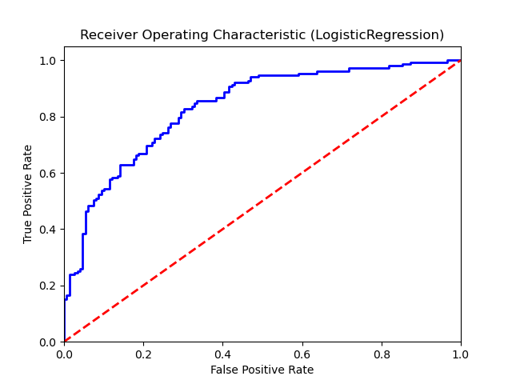

## Confusion Matrix:

True Negatives: 109

False Positives: 40

False Negatives: 35

True Positives: 116

## Confusion Matrix Plot:

